**If you do not receive a utility bill by the 10th of every month, please contact Anna City Hall. Failure to receive your utility bill does not relieve customers of payment obligations.**

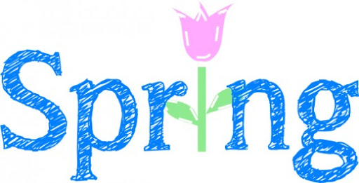

**During the 2020 Census, the Census Bureau will *never* ask you for:**

* **Your Social Security Number.**
* **Money or donations.**
* **Anything on behalf of a political party.**
* **Your bank or credit card account numbers.**

**Take charge & complete your census today!**

**For more information visit census.gov.**

**BIG TRASH PICK UP SUSPENDED**

Effective immediately, there will be some changes in the residential trash services due to the public health emergency caused by the coronavirus-19 (COVID-19) outbreak. Republic will not service any trash outside of the container, as we are trying to limit exposure to our drivers during this time. Additionally, in order to best protect and limit the exposure to our employees, **Big Trash pick-up at curbside will be suspended until further notice**. These measures are effective in all communities that Republic Services provides trash service. We appreciate your support and understanding as we know everyone is working hard to prevent exposure during this pandemic. Republic Services’ number one priority is the safety of our employees, customers and communities we service.

**CHILD ABUSE PREVENTION MONTH**

Every April, the Children's Bureau observes National Child Abuse Prevention Month to raise public awareness of child abuse and neglect, recommit efforts and resources aimed at protecting children and strengthening families, and promote community involvement through activities that support the cause.

**PAYMENT OPTIONS**

• Cash, Check or Money Order accepted at City Hall.

(No cash payments accepted in the night drop box)

• Direct Debit, the utility bill would be withdrawn on the due date out of a checking or savings account.

• Online, visit www.cityofanna.org and click on Utility Payments in the upper left-hand corner.

*The City of Anna is an Equal Opportunity and Employer.*

* **Utility Bill Due**

April 20, 2020 by 4 p.m.

* **5% Penalty on Utility Bill**

April 20, 2020 after 4 p.m.

* **$15 Penalty on Utility Bill**

April 21, 2020 after 4 p.m.

A Disconnection notice will be mailed.

* **Disconnection of Utilities**

May 4, 2020

Once services are disconnected, all bills must be paid in full, plus any additional fees, before utilities are reconnected.

* **City Council Meeting(s)**

April 7, 2020 at 5 p.m.

April 21, 2020 at 5 p.m.

* **City Hall will be closed**

April 10, 2020

in Observation of Good Friday

**APRIL 2020**

**CALENDAR OF EVENTS**